


Pick to cart bugs and improvements
Web document
Version 1.0 – 2022 02 14
Codeless Technology B.V.
Rijksstraatweg 7 | 3316 EE Dordrecht | The Netherlands
Contents
1. Revision 2
2. Summary 3
3. Requirements 3
4. Changes to be implemented 3
5. Dependencies 3
6. Testing 4
7. Estimations 4
8. Questions 4

Revision
Version | Date | Author | Modification
1.0 | 2022/02/14 | Dumitroaea Stefan | Initial document

Changes
On the Put Validate_TUID_PUT a new field should be sent, the id of the current picklist for which the TU-id is scanned :
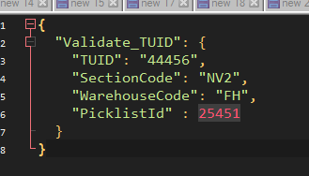
When pallet full is pressed on the screen :
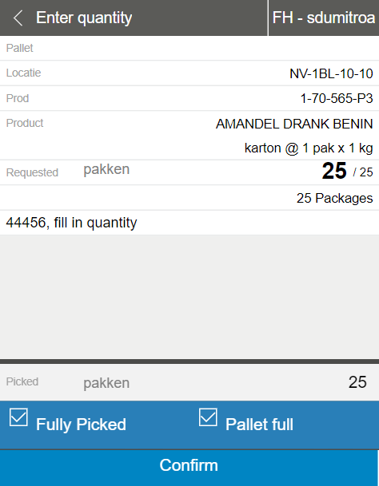
The next screen should say Scan new tu-id instead of scan old tu-id
